In a typical technical Upgrade project process steps like

1. **System preparation and stack level patch upgrade** – Basis Team
2. **SPDD Phase** – ABAP and Functional
3. **Upgrade of the system** – Basis Team
4. **SPAU Phase**– ABAP and Functional
5. **DBACOCKPIT for indexing** – (Issue resolution and error tracking) – ABAP TEAM and Functional
6. **Custom programs corrections** – obsolete function modules and objects

**PURPOSE-**  
All the objects which are modified, after transporting to the current system, will be listed in SPAU and SPDD. SPDD contains the list of all modified Data Dictionary objects, like tables, data elements, domains, view...etc. The rest of all the modified repository objects will be listed in SPAU.

**Flowchart:**  
System Preparation -> SPDD Phase -> Upgrade of the system -> SPAU/SPAU_ENH Phase  
  
**Object Modes & its Meaning:**  
All the objects present under transaction SPDD, SPAU & SPAU_ENH will have certain traffic lights or object modes associated to it.

* + Grey Light              –      Obsolete
  + Yellow Light            –      Semi Automatic Adjustment
  + Green Light            –       Automatic Adjustment
  + Red Light                –      Manual Adjustment
  + Green Tick Mark     –     Completely Adjusted

**Transaction SPDD:**

**SPDD Phase**

This transaction code SPDD is the core step in an upgrade project. The system compares all the dictionary objects – data elements, database tables and structures of the latest system with the previous or the old system.

These all elements are present under two nodes – with modification assistant and without modification assistant. Objects present under with modification assistant have the modification assistant ‘ON’ and we can see the modification logs. The objects in green color as shown below are the objects processed already and the ones in blue are the ones which still need to be processed. Apart from the nodes – ‘With modification assistant ‘and ‘Without modification assistant ‘, there is one more node sometimes – ‘Deleted objects. This node contains objects which are deleted in the newer version of SAP and this node is to be left as it is. The objects under ‘With modification assistant’ and ‘Without modification assistant’ are to be processed by the ABAP team.

When upgrading the SAP system, one of the initial steps that needs to be completed is SPDD. This will allow you to adjust modifications to ABAP Dictionary Objects during an upgrade.  
There are 4 categories in SPDD: a) SAP Notes b) With Assistant c) Without Assistant d) Deletions  
**Note:** SPDD will be carried out in shadow instance.

1. With Modification Assistant: ABAP Technical Consultant has to take appropriate action along with Functional Consultant.
2. Without Modification Assistant: Here also ABAP Technical Consultant has to take appropriate action along with Functional Consultant. Some manual changes can be done here by technical consultant.
3. Deleted Objects: This section shows deleted objects, and nothing can be done for this section.

**Key Points:**  
The keys aspects to take the action depends on two scenarios.

* **RESET:** If the customer modifications does not exist in the object and the changes are same w.r.t latest customer TR and the latest upgrade TR, then we can do reset to original.
* **ADJUST:**If the object contains any customer changes & the changes are not same w.r.t latest customer TR and the latest upgrade TR, then we need to perform adjust modification.
* **Example:** say a table MEDA is there in SPDD. When we click on it and go to the version comparison, suppose it shows that 2 new fields are added in the Latest SAP version (ECC), when compared to the older version (4.6c).The ABAPER has to analyze the pros and cons of this objects – If he resets the table to original in SPDD, the 2 new fields would be added in the table MEDA. If he Adapts modification, whenever any transaction or any program tries to store or read any value from the two new fields, it might give a short dump. So in this case, it is better to go for ‘Reset to original’.
* Considering another example, if say a data element say PRODH1 was of length say char7 in the previous versions where it had been modified by the user from char5 to char7 by the user for their business requirement, and again in the Latest SAP version, its char5, then it is better to adopt modification since in some transactions the user might be storing char7 values instead of char5.

**Steps;**  
1) Open Transaction SPDD

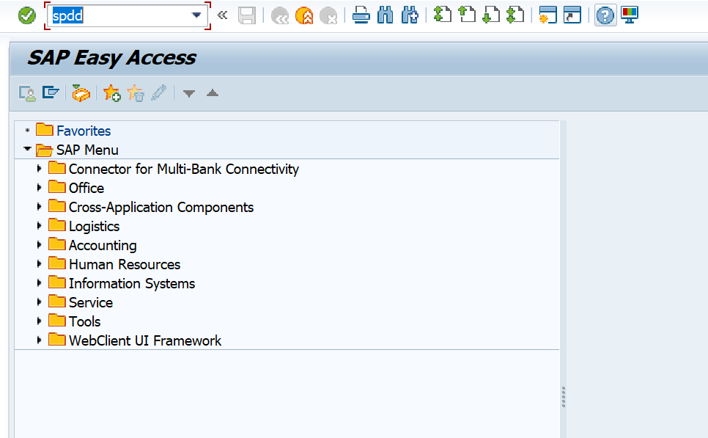

2) Execute normally or give appropriate fields in the selection.  
 Ex- for Vistex we choose /IRM objects.

Interface-1   
  
Interface-2

3) SPDD Objects are displayed under WITH and WITHOUT ASSISTANT tabs.

Interface-1   
   
Interface -2

The objects in green color are the objects processed already and the ones in blue still need to be processed.

The ABAP team clicks on the objects one by one – it takes us to the corresponding object – data element, structure or database table in the SE11 transaction code where we need to do the version comparison of the object. Click on Utilities -> Versions ->Version Management. There it shows all the versions of the object. The topmost or the latest version is of the Latest SAP Version and the versions below are the previous or modified versions.

NOTE - Active version must be compared with the version below upgrade or the Request which is displayed by different name other than TR below version (refer below screen shot).

Click on the check boxes of the two versions to compare and then click on the ‘compare’ button. We have to choose two and only two versions in order to compare them. In the comparison, it shows the differences in the two versions. We can click the Delta Comparison to see the delta differences between the two versions of the object. Now, after seeing the comparison, the developer has to decide whether he/she wants to keep the Latest SAP version of the object. (Reset to Original) or he/she wants to keep the changes made or modifications made (Adapt Modification) in the previous system.

Ex-

When we click on it and go to the version comparison, suppose it shows that 2 new fields are added in the Latest SAP version, when compared to the older version. The developer has to analyze the pros and cons of this objects – If he/she resets the table to original in SPDD, the 2 new fields would be added in the table MARA. If he Adapts modification, whenever any transaction or any program tries to store or read any value from the two new fields, it might give a short dump. So, in this case, it is better to go for ‘Reset to original’.

Click on object -> Click on Utilities -> Versions ->Version Management

here comparing the versions-> active version with the version below upgrade.

here comparing the versions-> active version with the version below SAP change (or different name other than request is considered as upgraded version).

* NO CHANGE –  
  If there are no changes to the compared versions, below message is displayed either as unchanged or “there are no differences in the sources of these version”.  
  for this we reset the object to original.

go to the initial screen of SPDD->select the object-> double click on Reset (visible in the right side of the screen)-> capture in the TR given for SPDD-> refresh.

After RESET and capturing into the transport request, the below icon is being displayed, click on refresh icon on the top. The item will be moved from the area and will be displayed in the TR.

* CHANGE –  
  here the object(structure) has changes, the include structure is deleted in the active version in this case – check whether the deleted structure is needed in the new version if needed include it if not ignore, reset.

Similar scenarios of spdd-change objects.

The objects which have change, after reset and manual correction is done the object status is displayed as green tick mark as shown below.

If had to reset all objects, we can select directly by using CTRL+ select object and reset all objects as shown below.

**Transaction SPAU:**

**SPAU Phase**

The SPAU transaction contains the objects – Programs, Reports, Screens, Messages, Notes, Function Modules etc. which have difference in the Latest SAP request and the previous ones. This SPAU phase can be done either just after SPDD or after the Upgrade of the system by the Basis team.  
  
The same way we need to compare the objects in ‘Version Management’ and decide whether to ‘Reset to Original’ or ‘Adapt Modification’. The ‘Adapt Modification is however slightly different for codes – Function modules, reports etc.   
  
This process starts after completion of SPDD phase and is used to adjust repository objects like programs, screens, functions, classes, etc.  
There are 5 categories in SPAU: a) SAP Notes b) With Assistant c) Without Assistant d) Deletions e) Translations  
**Note:** Unlike SPDD, this can be carried out in the normal client.

**WITHOUT MODIFICATION-**  
The Modification is however slightly different for codes – Function modules, reports etc. In adapt modification, the SPAU gives us the empty space to write our code – by having a reference to the code in previous request, we can decide and write the code with some corrections when required. This is in the case of objects present in ‘Without Modification Assistant’.

**WITH MODIFICATION-**In case of ‘With modification Assistant’, it opens the program code in grey mode, and we can insert or delete or modify code by pressing corresponding buttons in a similar way we do to modify any SAP standard code by using the access key.

**Steps;**  
1) Open Transaction SPAU

2) Execute normally or give appropriate fields in the selection.  
 Ex- for Vistex we choose /IRM objects.

3) SPAU Objects are displayed under WITH and WITHOUT ASSISTANT tabs.

The ABAP team clicks on the objects one by one – it takes us to the corresponding object – Programs, Reports, Screens, Messages, Notes, Function Modules etc. we need to do the version comparison of the object. Click on Utilities -> Versions ->Version Management. There it shows all the versions of the object. The topmost or the latest version is of the Latest SAP Version and the versions below are the previous or modified versions.

NOTE - Active version must be compared with the version below upgrade or the Request which is displayed by different name other than TR below version (refer below screen shot).

Click on the check boxes of the two versions to compare and then click on the ‘compare’ button. We have to choose two and only two versions in order to compare them. In the comparison, it shows the differences in the two versions. Now, after seeing the comparison, the developer has to decide whether he/she wants to keep the Latest SAP version of the object. (Reset to Original) or he/she wants to keep the changes made or modifications made (Adapt Modification) in the previous system.

Check objects if there is no difference reset the object. if change, get confirmation with functional whether to implement those changes.  
if yes, capture the change and keep as backup and then reset the object, add the change activate.

Scenarios of code difference-

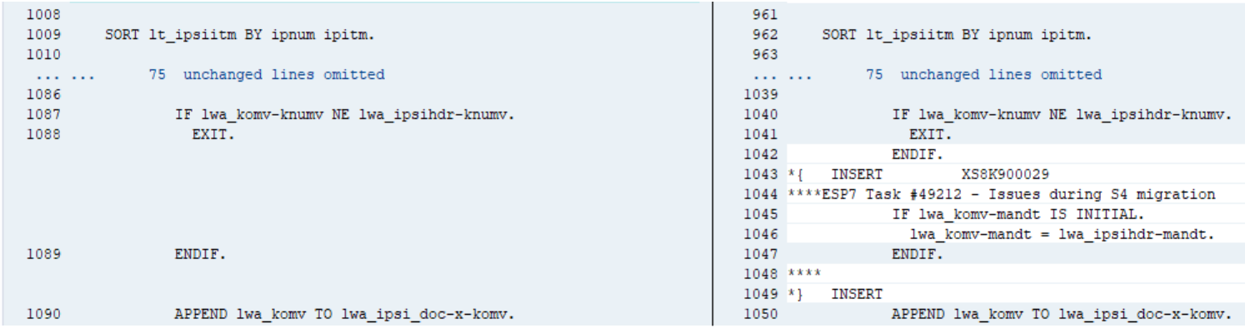

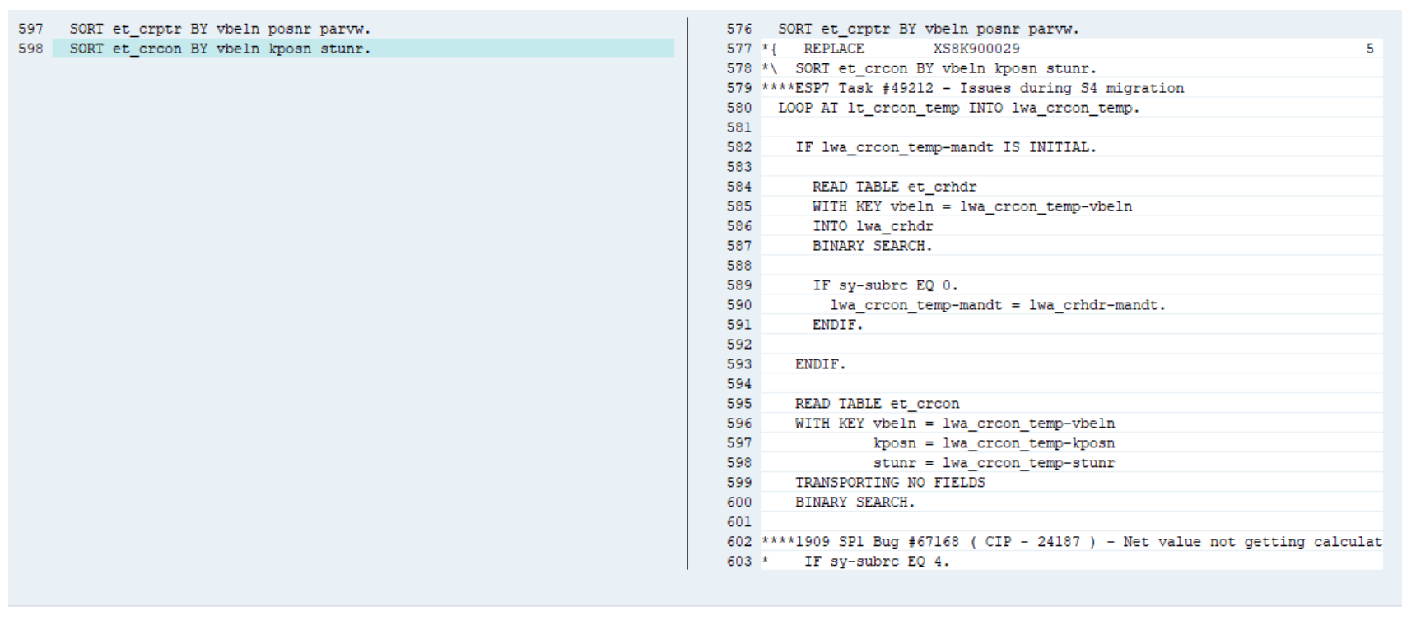

**Transaction SPAU_ENH:**  
This is used to adjust custom enhancements.

Ex-

Object Name: ZVX_EN_AGREEMENT_DELETION

Steps:

1)Double click on the object and go to change mode

2)Click on the highlighted button below:

3)Click on the Activate button.

4)Then it will ask for the transport, choose our transport request.

5)Done. Then the object will disappear from the left-hand side.

If BADI:

Object Name: ZVX_ES_GPS_ALL

Steps:

1)Double click on the object and go to change mode

2) Click on the Adjust Enhancement Implementation, (it shows an information msg the object cannot be adjusted automatically)

3)Click on Adjustment tab and click on the entry, you can see the newly created methods

4)go to that Class check for the methods and activate the new methods in that class (ZVX_EX_BADI_GPS_ALL)  
5) Again open the new session, object will be disappeared.